UNUSUAL HOTELS

My unusual hotel looks like a very old and scary building from outside, but in fact it’s a new building with an old facade design. The interior is very modern and fashionable. The hotel has three overground floors, a main floor and one basement. On the three overground floors are rooms, on the main floor are reception, a luxury restaurant, a bar and a coffee house. If I were you, I would try the swimming pool, sauna, billiard and the gym, which you can find on the basement. If you like flowers and trees, you will enjoy the huge garden with the fountain. The hotel also has five outdoor tennis courts and three indoor courts. The tennis club is the owner of courts, but if you want, you can play tennis, even if you stay here. If you’re billeted here, the price on the outdoor court is 10 € per hour and on the indoor court 19 €, but if you’re not, the price is 13 € per hour on the outdoor court and 22 € on the indoor. If you want to play outside you can play on clay, but if you prefer hard court you can play inside. If you wish, there are also professional tennis trainers available, but the prize is about 9 € higher. Tennis camps are organized here all thought the year. For camp participants there is half discount on everything, because they usually stay here for month or longer and with normal prizes it would be too expensive. Tennis club organized national, but even international tournaments all the year around, so when there is a tournament, you can order just outdoor or just indoor court, according as it is played outdoor or indoor. One free entry to the swimming pool, sauna and the gym is included in the total prize for normal guests. Billiard and other games are extra paid. Drinks and meals from restaurant, bar and coffee house are not included in the total prize. This hotel has 24 rooms and 6 luxury apartments for guests. There are 9 single-bed and 15 double-bed rooms. Every room have a balcony. From there you have a view directly on the tennis courts, so you can follow the ongoing matches and practices. The staffs are nonstop in the hotel. They have 8 hour shifts, so they have exchanges three times a day. If I were you, I would definitely visit this hotel.

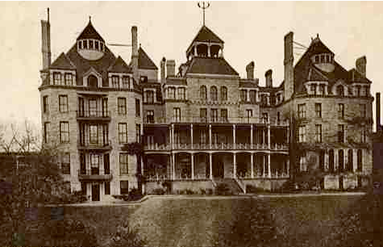
Hotel from outside
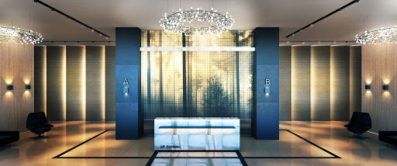
Reception
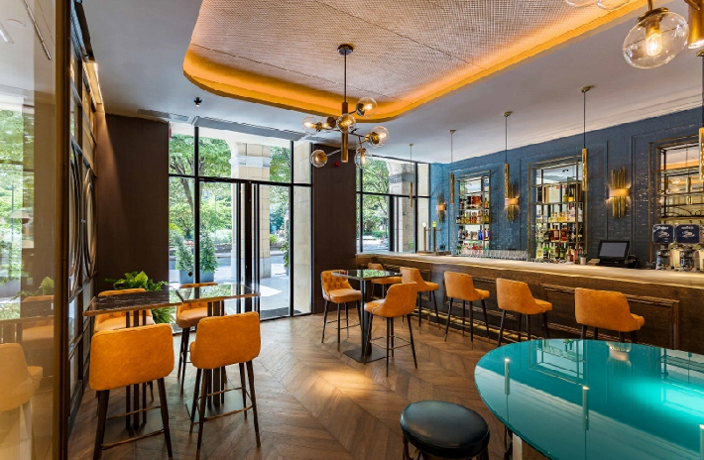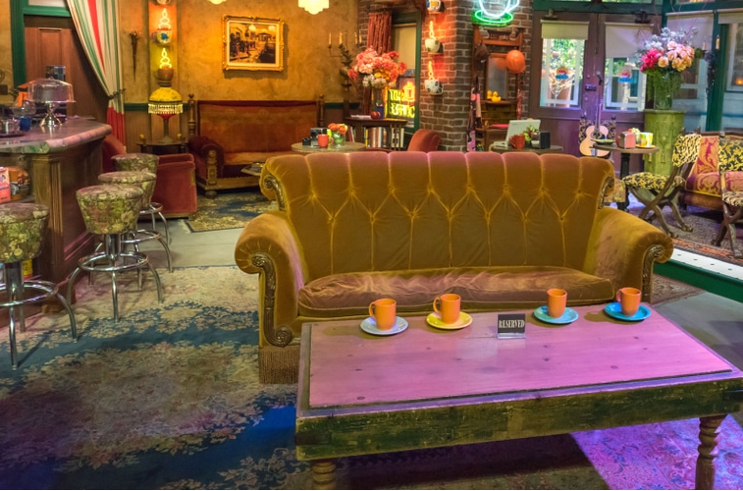
Hotel bar Coffee house
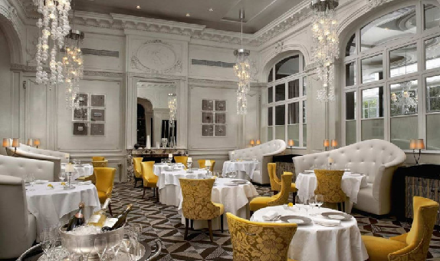 Luxury restaurant

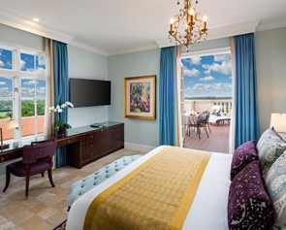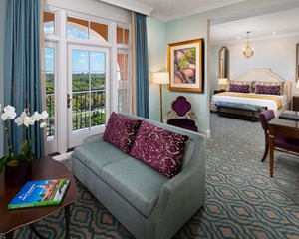
Double-bed room Luxury apartment
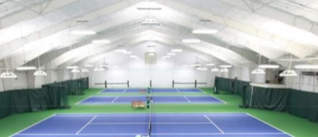
Indoor hard courts
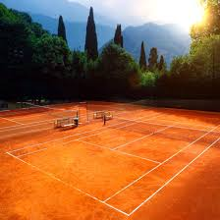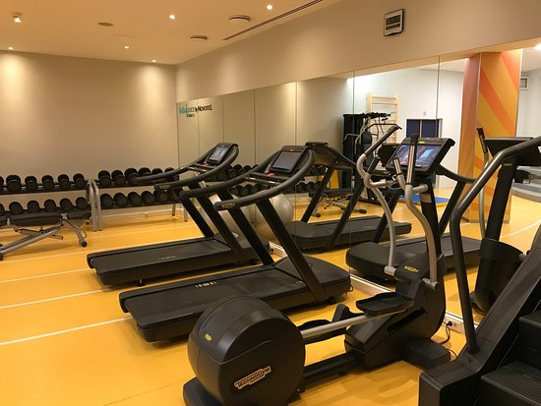
2 of 5 outdoor clay courts Gym
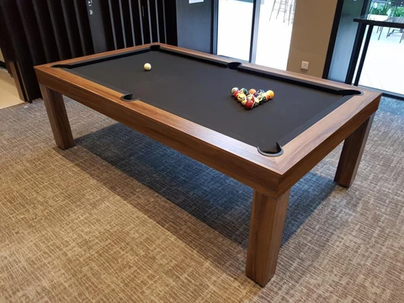
Billiard
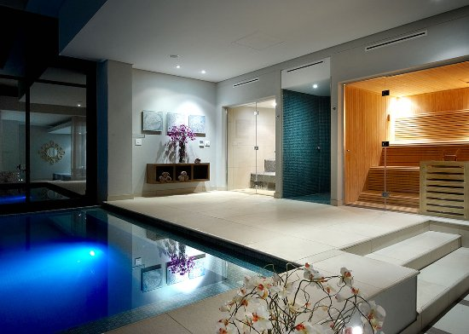
Swimming pool and sauna

