ZBER GAŠTANOV
PORADIE TRIED
MIESTO | TRIEDA | KG
1. | III.A | 325
2. | V.I | 203
3. | IV.B | 192
4. | III.B | 187
5. | VIII.A | 149
6. | I.B | 135
7. | IV.A | 133
8. | II.A | 101
9. | I.A | 53
10. | VII.A | 40
11. | IX.A | 40
12. | V.A | 36
13. | VIII.B | 35
14. | II.B | 20
15. | VI.B | 20
16. | VI.A | 11
17. | IX.C | 10
18. | VII.B | 0
19. | IX.B | 0
SPOLU: |  | 1690
SUPER gratulujeme!!!
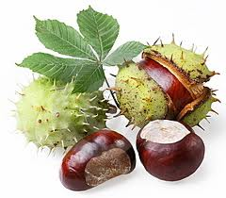

MIESTO | MENO | KG | trieda
1. | Oliver Leškanič | 260 | III.A
2. | Natália Diaková | 123 | V.I
3. | Dominik Belopotočan | 112 | VIII.A
4. | Tamara Sádovská | 83 | III.B
5. | Ema Demová | 70 | IV.B

